SQL Task

**College Management System ER Diagram:**

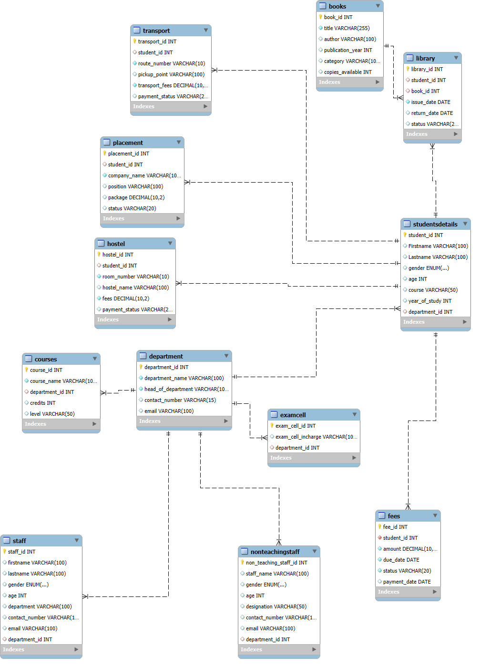

Explanation:

Department table:

The department table contains the department_id, department_name, head_of_department, contact_number, email. This all entity’s there in the department table. In this table department_id is primary key.

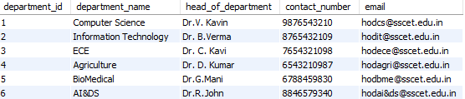

2. Student details table:

In this student details table contains the student_id, firstname, Lastname, gender, age, course, year_of_study, department_id. In this table have the student_id is primary key and foreign key is department_id for identify the student which department.

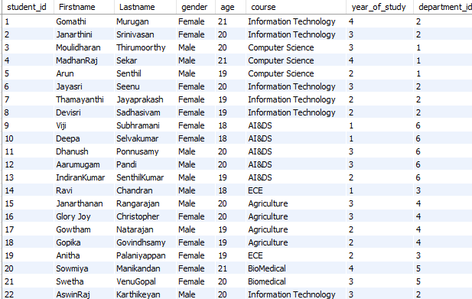

3. Fees details table:

In this table contains the fees_id, student_id, amount, due_date, status, payment_date. This table primary key is fees_id and foreign key is student_id. The student_id can help identify the student fees.

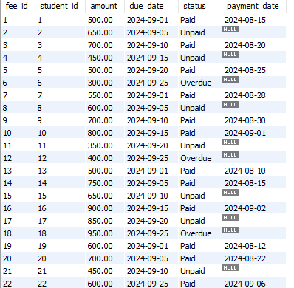

4. Staff table:

In this staff table contains the staff_id, firstname, lastname, gender, age, department, contact_numbar, email, department_id. This table primary key is staff_id and foreign key is department_id. The department_id can easily identify the staff which department.

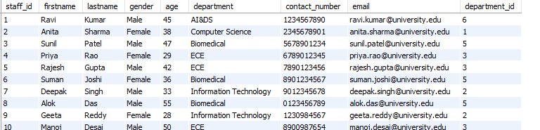

5. Exam cell table:

In thos table contains the exac_cell_id, exam_cell_incharge, deparment_id. This table primary key is exam_cell_id and foreign key is department_id.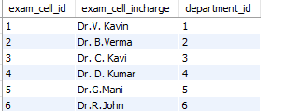

6.Course table:

In this course table contains the course_id, course_name, department_id, credits, level. This course table primary key is course_id and foreign key is department_id. Department_id can easily identify the what are the course in the department.

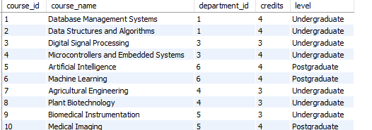

7. Book table:

In this book table contains the book_id, title, author, publication_year, category, copies_available. This table primary key is book_id.

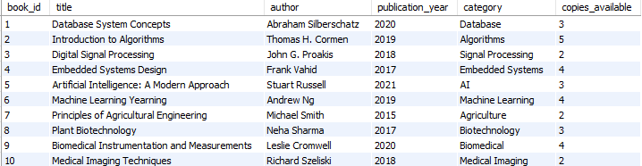

8. Library table:

In this library table contains the library_id, student_id, book_id, issue_date, retrun_date,status. This table primary key is library_id and it contains two foreign keys one is student details from student_id which student should take the books and another one is book table from book_id which book should taken the identification.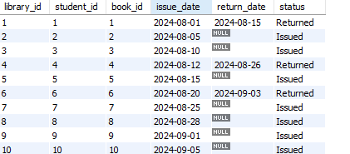

9.Hostel table:

In this table contains the hostel_id, student_id, toom_number, fees, payment_status. This table hostel_id is primary key and student_id is foreign key. The student_id should represent the which student is hostel.

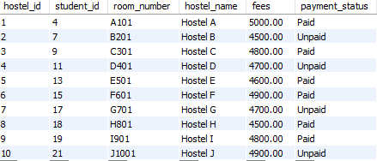

10. Placement table:

In this placement table contains the placemet_id, student_id, company_name, position, package, status. This table placement_id is primary key and foreign key student_id. The student_id can identify the which student placed.

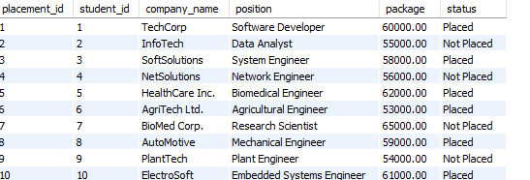

11. Transportation table:

In this table contains the transport_id, student_id, route_number, pickup_point, transport_fees, payment_status. This table primary key is transport_id and foreign key is student_id. Student_id can represent the which student can use the transport service.

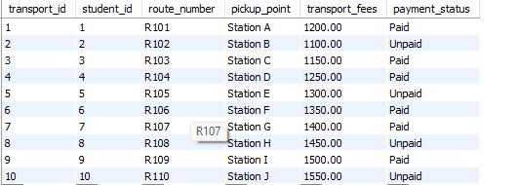

12. Non-teaching staff table:

In this table contains the non_teaching_staff_id, staff_name, gender, age, degignation, contact_number, email, department_id. This table primary key is non_teaching_staff_id and foreign key is department_id. The department_id can represent the the staff can work which department.

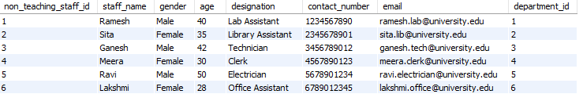

**Social Media ER Diagram:**

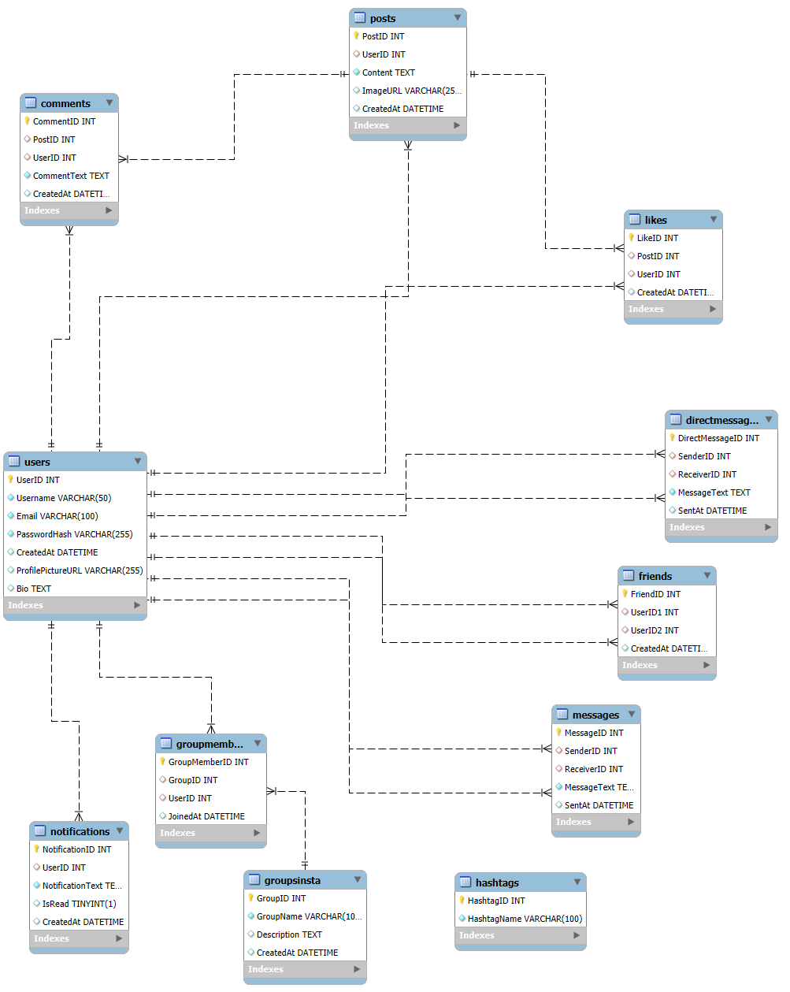

Explanation:

1.User table:

The table contains the UserID, Username, Email, Password, Account created date with timestamp, profile picture URL and Account bio. This all Entities are there in the user table. In this table primary key is user ID for user identification.

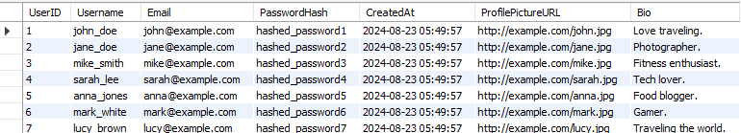

2. Post table:

The table contains the PostID, UserID, Content, ImageURL, the post posted date with timestamp this all columns are there. In this Post table primary key is PostID and foreignkey is UserID. The user ID can represent the which user can Post the posts identification.

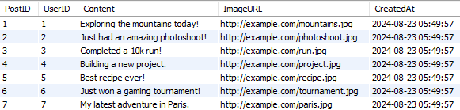

3. Comment table:

The comment table contain the CommentID, PostID, UserID, CommentText, the comment created date with timestamp. This table primary key is CommentID. In this table using the two foreign keys at the Post ID in the post table and user ID can use the user table. The post ID can identify the which post and the user ID can represent the which user can Post the posts identification.

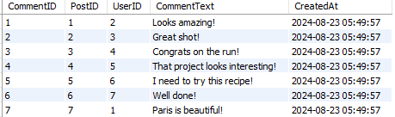

4. Like table:

The like table contain the LikeID, PostID, UserID, the comment created date with timestamp. This table primary key is LikeID. In this table using the two foreign keys at the Post ID in the post table and user ID can use the user table. The Post ID can identify the which post and user ID can represent the which user can Post the posts identification.

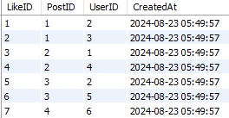

5. Friend table:

The friend table contains the frienDID, userID1, userID2, created time and date. This table contains the primary key is FriendiD. In this table have two foreign keys at user table in user ID but represe the users can friend with many people.

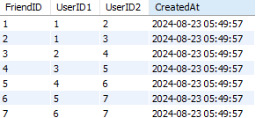

6. Message table:

The Message table contains the MessageID, SenderID, ReceiverID, MessageText, message sending date with timestamp. The primary key of the table is MessageID. In this table two times using user id in foreign key. The forigren key one contain the message sender and another foreign key receiver.

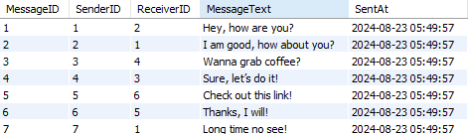

7. Notification table:

The notification table contains the notificationID, userID, NotificationText, IsRead, Created at date and timestamp. The primary key of the table is NotificatonID. In this notification table have one foreign key at the user ID in the user table.

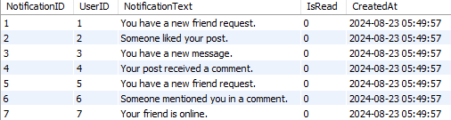

8.Group table:

The group table contains the GroupID, GroupName, Deccription, createdat with date with timestamp. The primary kry of the table is GroupID.

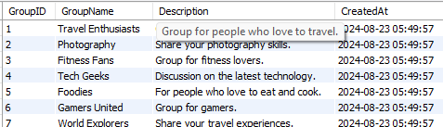

9. Group Members table:

The group members table cotanis the group MemebersID, GroupID, UserID, JoinedAt date with time stamp. The primary kry of the table is GroupMemberID. In this table have the two foreign keys. One is User table is User ID and another one is group table is Group ID representation.

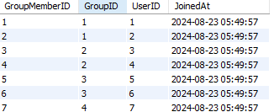

10. Direct Message table:

The table contains the DirectMessageID, SenderID, ReceiverID, MessageText, SendAt. The primary key of the table is DirectMessageID. In this table contains foreign key is UserID but two different entities one is SenderID and another one is ReceiverID.

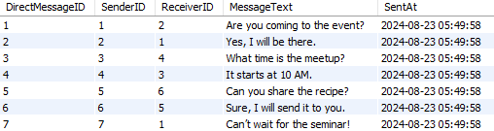

11. Hashtag Table:

In this table contains the HashTagID, HashTagName. The Primary key is HashTagID.

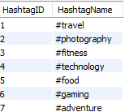

**Food Delivery ER Diageram:**

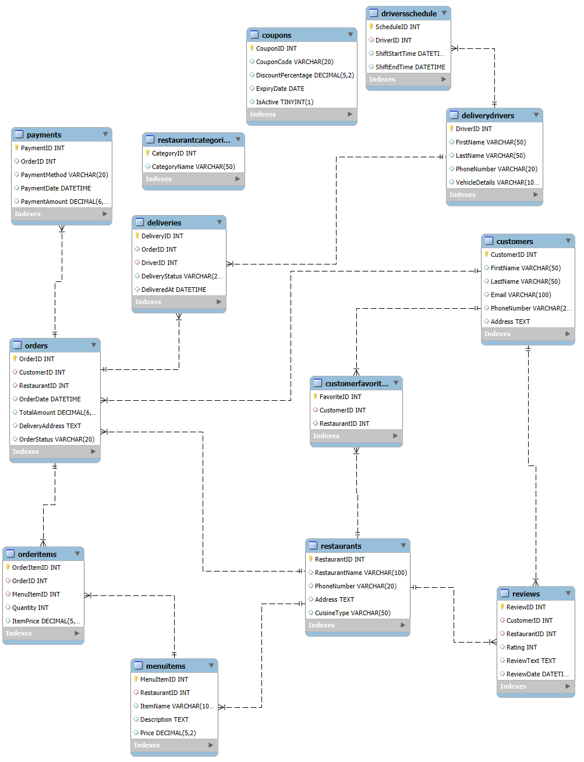

1.Customer table:

In this customer table contains the CustomerID, FirstName, LastName, Email, PhoneNumber, Address. The primary key of the table is CustomerID

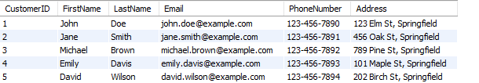

2.Restaurant table:

In this table contains the RestaurantID, RestaurantName, PhoneNumber, Address. The primary key of the table is RestaurantID.

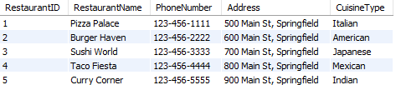

3. MenuItem table:

In this table contains the MenuItemID, RestaurantID, Item name, Description, Price. The primary key of the table is MenuItemID and the foreign key of the table is RestaurantID. The RestaurantID can represent the which restaurant can provide the menu items.

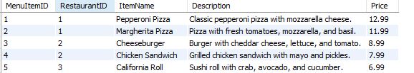

4.Order table:

In this order table contains the OrderID, CustomerID, RestaurantID, OrderDate, TotalAmount, DeliveryAddress, OrderStatus. This table primary key is OrderID and this table contains the two foreign keys one is Customer table from CustomerID then another one is Restaurant table from RestaurantID. The foreign keys help to find the which customer which restaurant can order their foods.

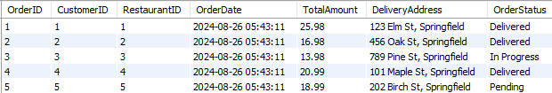

5. Order Items table:

In this table contains the OrderItemID, OrderID, MenuItemID, Quantity, ItemPrice. The primary key of the table is OrderItemID. In this table have two foreign keys one is OrderID and another one is MenuItemID. This foregin keys represent the orderID and MenuItemID.

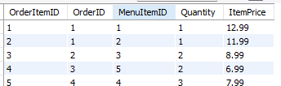

6. Payment table:

In this table contains the PaymentID, OrderID, PaymentMethod, PaymentDate, PaymentAmount. The primary key of the table is PaymentID and the foreign key of the table is OrderID. The OrderID can represent the placed the order and find the payment details.

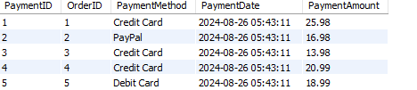

7. Delivery Derivers table:

In this table contains the DriverID, FirstName, LastName, PhoneNumber, VehicleDetails. The primary key of the DriverID.

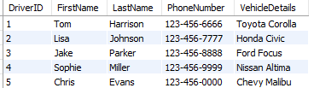

8. Deliverles table:

In this table contains the DeliveryID, OrderID, DriverID, DeliveryStatus, DelivereAt. The primary key of the table is DeliveryID. In this table contains the two foregin keys one is OrderID and another one is DriverID. It can represent the delivery progress.

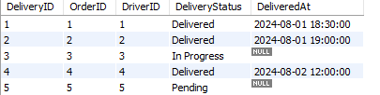

9. Review table:

In this contains the ReviewID, CustomerID, RestaurantID, Rating, ReviewText, ReviewDate. The primary key of the table is ReviewID and it contains two foreign keys one is CustomerID another one is RestaurantID. The foreign keys should represent the which customer give the review and which restaurant to get the review.

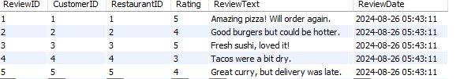

10. Coupon table:

In the coupon table contains the CouponID, CouponCode, DiscountPercentage, ExpiryDate, IsActive. The primary key of the table is CouponID.

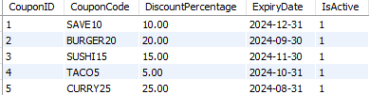

11. Schedule table:

In this table contains the ScheduleID, DriverID, Shiftstartime, ShiftEndTime. The primary key of the table is ScheduleID and the foreign key of the table is DriverID. The DriverID can represent the white time deliver the food.

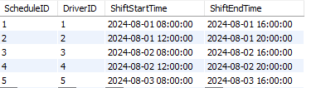

12. Restaurant Categories table:

In this table contains the CategoryID and CategoryName. The primary key of the table is CategoryID.

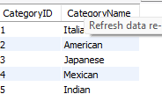

**Attendance Automation:**

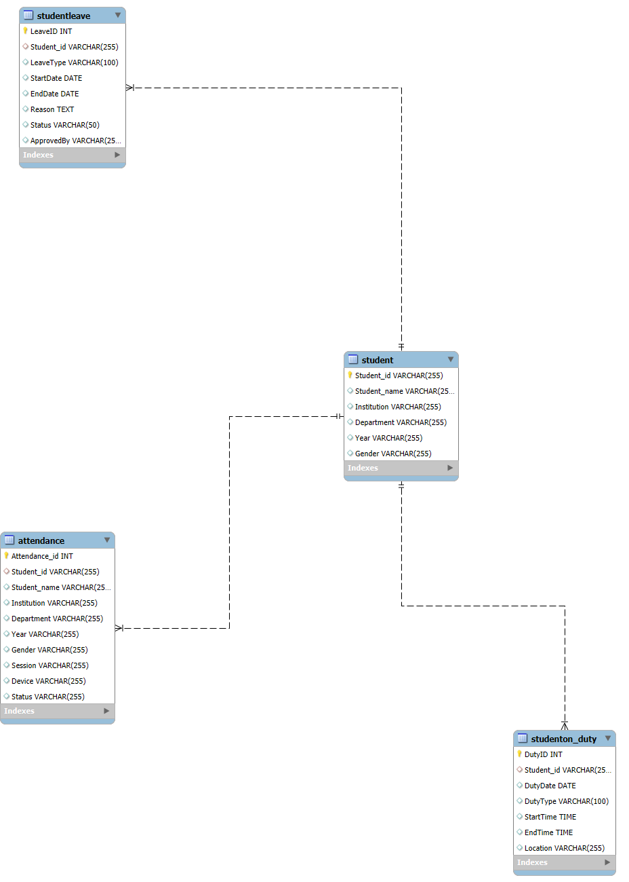

Explanation:

1.Student Table:

The student table contains the Student_id, Student_name, Institution, Department, Year, Gender. In this table primary key is Student_id.

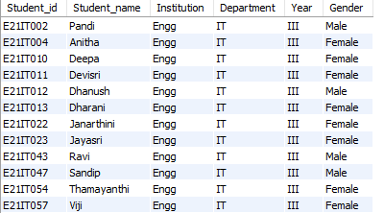

2. Attendance table:

In this table contains the Attendance_id, Student_id, Student_name, Institution, Department, Year, Gender, Session, Device, Status. The primary of the table is Attendance_id and the foreign key is Student_id. The student_id can represent the which students present and absent.

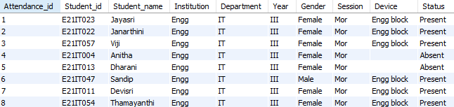

3. On-Duty table:

In this table contains the DutyID, Student_id, DutyDate, Dutytype, Starttime, EndTime, Location. The primary key of the table is DutyID and foregin key of the table is Student_id. The Student_id can find the which student are there in the On-Duty.

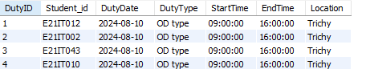

4. Leave table:

In this table contains the LeaveID, Student_id, LeaveType, StartDate, EndDate, Reason, Status, ApprovedBy.the primary key of the table is LeaveID and foregin key is Student_id.

